REMOVES BIOFILM, LEGIONELLA AND OTHER DANGEROUS MICROORGANISMS

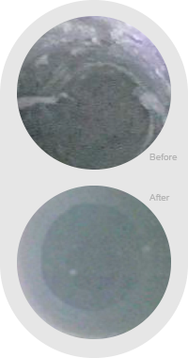

TECHNOLOGY OVERVIEW

MOS is not the same as Chlorine Dioxide. While MOS provides similar disinfection benefits to Chlorine Dioxide, the chemical generation process is safe and easy to maintain because MIOX systems use a salt/water brine solution to create a powerful, non-hazardous disinfectant.

MIXED OXIDANT SOLUTION

The MIOX on-site chemical generator can feed disinfectant directly into the distribution system. In order to provide continuous disinfection, maintain residual and reduce risk, MOS chemistry is recommended to be fed continuously. At normal doses of 1-4 ppm, MOS is not corrosive to building distribution piping.

HOW IT WORKS

Mixed Oxidant Solution (MOS) is extremely effective at killing planktonic (free-floating) Legionella at concentrations between 0.5 - 4 mg/L. The short story on MOS is that it’s sodium hypochlorite plus trace amounts of hydrogen peroxide. These two chemistries work in conjunction to break up and remove biofilm, which is key in keeping legionella under control. Legionella itself is easy to kill in free-floating form, but tends to harbor in biofilm. When the biofilm sloughs off, it carries the Legionella with it, which can then be aerosolized in showers, spas, etc. By removing or controlling biofilm, you eliminate Legionella.